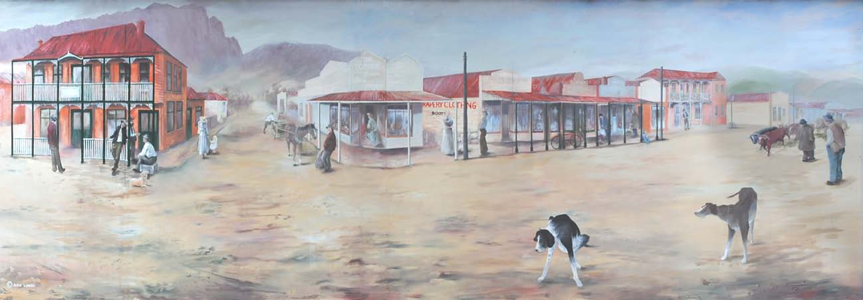

PUBLIC ARTS COMMITTEE KENTISH (PACK)

OPERATIONAL GUIDELINES/CODE OF PRACTICE

Adoption by Council October 18 2011
Minute Number: 11.5.3
1 INTRODUCTION

In response to community demand and the growing desire in the community to further develop public art, the Kentish community has expressed a desire to form an independent committee to handle all public art in Kentish and remove Murals from the planning scheme. The new Public Arts Committee Kentish (PACK) will accept applications for all new proposed artworks and modifications to existing works. The applications will be assessed in accordance with the Kentish Community Arts Policy. The PACK will function as per the Public Arts Committee Kentish Operational Guidelines/Code of Practice here in. However, whilst the PACK will have full autonomy as a special committee of Council, it will still be necessary to operate alongside the Kentish Council Planning Scheme until such time as the Scheme is amended.

2 THE ROLE OF THE PACK

The role of the Public Arts Committee Kentish (PACK) will be to invite and assess applications from the community for all Public Art Work proposals. The PACK will act as a broad consultation mechanism representing as broad a cross section of the community and arts professionals as practicable.

The PACK will assess and consult based on the spirit and content of the Kentish Community Public Art Policy Review and Content criteria as outlined in this document and operate under the procedures and structure outlined below.

3 COMMITTEE MAKE UP

The PACK will have the following permanent members:

• An art teacher, arts academic (or someone with an arts education background), a curator, gallery director or other arts professional. This individual will be approved by Council and Tasmanian Regional Arts;

• A representative of Tasmanian Regional Arts Kentish (TRAK);

• A representative of Sheffield Inc.;

• A representative of Mural Fest;

• A representative of any interest group within the Kentish municipality;

• A representative of the broader community;

Temporary Membership:

Should a work be proposed for an area of the municipality that has no current representation on the PACK, a representative of that Community will be invited to sit on the committee for the duration of any proposed project.

4 GOVERNANCE

The PACK will be an autonomous Special Committee of Council. Representatives will be elected to the committee by the local ratepayers' organisations of the relevant communities (e.g. a Railton representative for a Railton project, a Wilmot representative for a Wilmot project). Tasmanian Regional Arts (TRAK) and Sheffield Inc. will elect a representative to the committee. A suitable arts academic will be sourced by the PACK, once established.
Members of represented communities will serve for a maximum of two (2) years, TRAK, Sheffield Inc. and engineering professional for three (3) years and the representative of the academic community for four years (4). * Representatives that have previously served on the Committee will be eligible for re-election after a period of two years absence.

Meetings of the PACK will take place as required to assess proposals.

Applications for public art will be considered within 30 days. The Committee will assess all works following guidelines and methods set out within the Kentish Public Arts Policy. Decisions will be made by simple majority support.

The Committee will inform the applicant of all decisions. The Committee will ensure that any proponent is fully aware of the review procedures, artist’s submission requirements and the right of appeal.

The Committee will endorse this document as a code of practice upon its establishment, in the best interests of public art.

5 EXTENT OF AUTHORITY

The Public Arts Committee Kentish will be given fully delegated authority as a special committee of Council to approve or decline works in the municipality. Three-dimensional works will also be assessed by PACK in its role as an arts development mechanism but remain subject to normal planning approval under the Kentish Council planning framework.

6 PUBLIC ARTS POLICY

The Public Arts Committee Kentish will be responsible for undertaking an annual review of the application review criteria contained in the Kentish Community Public Arts Policy and shall make revisions as needed.

7 ARBITRATION

The Public Arts Committee Kentish (PACK) will be the final arbiter once the appeals process has been exhausted.

8 INDEPENDENT ADVICE

The PACK will seek independent advice from a suitably qualified professional or expert in the field should advice be required in relation to: structural integrity; social and cultural impact; environmental and ecological impact; indigenous significance; heritage limitations; or public safety.

9 GUIDELINES FOR DEALING WITH CONTENT

When dealing with content in assessing the suitability of a particular work, a number of factors should be considered by the PACK prior to making a final decision:

Location

Context within an established precinct (e.g. if historical works frequent a precinct, is a contemporary work appropriate and vice versa? Is it appropriate to modify the work without affecting artistic integrity? Is an alternate location appropriate? Is an alternate medium an option?);
Potential impact or precedent for a new arts area;

Is the area frequented by a particular sub culture, and does the work reflect that sub culture? (e.g. is it an appropriate piece for a recreation facility, youth facility, antiques store etc);

Where possible, if a work is deemed inappropriate for a specific location, the committee will liaise with the applicant to endeavour to identify an alternative site;

Is it compatible with any overall streetscape or municipal development plan?

Precedent

Is there an established artistic or architectural precedent for the work in regard to genre, medium and/or subject matter? (e.g. romanticism, art deco, impressionism, abstract etc);

Where no precedent exists, consideration should be given to the potential of the work to break new ground or conflict with existing pieces in the Kentish collection.

Community Context

Median age and background of surrounding residences;

Likelihood of negative community reaction based on location and content; Evidence of wide community support for the proposal;
Source of the proposal - e.g. arts group, individual, business alliance, etc. i.e. does it have demonstrated community support through a group initiative.

Surrounding Art Works and Infrastructure

Does the proposal compliment any existing public art works?

Will surrounding infrastructure be negatively impacted visually or enhanced by the proposal?

Impact upon Sensitive Audiences

Regardless of checks and balances exercised by the committee, all art works by their very nature have the potential to offend and challenge community preconceptions and ideologies. As such it is important to consider public sensitivities to a proposed work. These works should not be omitted, but handled carefully in the interests of community cohesion. Examples may include: contemporary interpretations of the Crucifixion of Christ; works that contain nudity; works that depict violence or have graphic depictions of disturbing scenes (e.g. war, cruelty); supernatural depictions; depictions of extreme poverty, etc.

Where a proposed art work could potentially be controversial due to its subject matter or form, further matters for consideration include:

• Is it a gateway work (i.e. the first impression visitors get of a locality)?

• Comparative location to schools and childcare centres;

• Comparative location to church and religious groups;

• Comparative location to special interest groups;

• Community History (e.g. the graphic depiction of a massacre in a town’s history could cause significant distress).
Inappropriate Works

The Public Arts Committee Kentish will be charged with the approval/ rejection of all proposed art works in the Kentish municipality, excluding Mural Fest entries. It is therefore vital that all works are thoroughly assed against all criteria in this document. Regardless of any other criteria the following works are to be considered inappropriate:

• Works that could reasonably be considered profane;

• Works that are defamatory of any individual, community, business, place, persons or period;

• Works that incite hatred, constitute prejudice or racism or clearly elicit cultural tension;

• Pornographic works (For the purposes of this policy, pornographic works are defined as; Containing an explicit depiction of sexual activity, usually depicting something in unnecessary detail).

10 CONSULTATION WITH CUSTODIANS OF SPECIFIC GENRES AND EXISTING WORKS

Where a work is proposed for an area where a current dominant genre is already established, consultation should take place with the custodians of the current precinct as a first point of call for the committee. Currently, recognised custodians include:

International Mural Fest Committee All mural works directly associated with the Annual International Mural Fest event (excluding acquisitions)

Sheffield Inc. Sheffield Historic Murals

Lorinna Residents and Ratepayers Association Lorinna Community Precinct

Kentish Council Sykes Sanctuary monuments*
Murals on public buildings outside Sheffield
Streetscapes and Street Furniture Mural Fest acquisition works Hopes Mill Corner*
Public Parks and Reserves

*Indicates custodianship in consultation with another group or individual

All custodians will be asked to keep a register of their art works and a copy retained by the PACK.
The PACK will update any registers as new art works are installed, as per the example below:

Description/ Photo
Installation  Date | Artwork  Name | Artist | Medium | Approx.  Value | Last  Inspection | Next  Inspection | Custodian | Physical  location
12/12/2013 | Terra  Firma | Pablo  Smith | Bronze  Sculpture | $15,000 | 12/12/2013 | 12/12/2016 | Roland  Gallery | 100  Holmes Rd, Roland
Bronze sculpture of Mount Roland depicting early pioneers in Mt Rushmore style. Approximate dimensions
4.5m x 4m x 7m...............................................................................................................................................

.....................................................................................................................................................................

EXAMPLE

11 DECOMMISSIONING PROCEDURES

In line with the guidelines established for dealing with decommissioning in the Kentish Community Public Arts Policy, consideration may be given to the removal of long-term installed artworks from public places when the artwork ceases, materially or conceptually, to function as an integral artwork. The Public Arts Committee Kentish is responsible for assessing the collection and decommissioning.

Decommissioning would generally be undertaken in instances where:

a) The artwork no longer functions materially;
b) The artwork has been irreparably damaged;
c) The artwork has physically deteriorated to a point where public safety is at risk.

Assessment

Before an artwork may be decommissioned it must be assessed against the following criteria:

A) The artwork no longer functions materially;

Most notably in the case of a three dimensional work, weathering of sub structures, decay of outside coatings, general design failure and/ or ground and base failure could all lead to the need to decommission a work. Generally this would be undertaken where the artwork no longer resembles the finished product as the artist intended. Ideally, where possible, works should be repaired in the first instance to renew design integrity. However, where this is not possible or price prohibitive, a work may need to be decommissioned. In each case the Artist and/ or Custodians of the piece should be contacted as to the condition of the piece to receive feedback on the viability of repair, wishes of the artist and how any damage or negative aging can be rectified.

B) The artwork has been irreparably damaged;

In the case of irreparable damage due to vandalism, weathering or structural failure, decommissioning becomes a necessity in managing the overall integrity of the Kentish Public Art Collection. In this instance the following procedure will be followed by the PACK:
• The PACK contacts the Artist and/ or Custodian of the work and advises of their recommendation to decommission;

• The PACK seeks repairs to be done to the work and/ or clarifies that the work is unable to be repaired;

• Upon confirmation of the above, the PACK gives the Custodian/ Artist a minimum of 30 days notice of the intention to decommission;

• The artwork is decommissioned.

Upon decision to decommission, the artwork is to be disposed of in the following descending order of priority:

1) Offered back to the artist for an appropriate consideration;
2) Transferred to an appropriate collection for an agreed consideration;
3) Sold to approved buyers with the consent of the Artist;
4) Donated to a recognised charitable institution; or
5) Sent to a materials-based recycling depot.

All revenue obtained through the decommissioning process will be retained by the PACK for consideration in future Art developments.

The final decision to decommission an artwork rests with the Public Art Committee Kentish. Where the work resides on private property, the PACK will work with the owner regarding any decommissioning to be undertaken.

C) Artistic merit of the work falls below the level to which the collection aspires;

Where the artistic merit of a work has fallen below the standard to which the Kentish Public Art Collection aspires in the case of a commissioned work or due to damage.

Content, materials, location or genre is significantly different to that approved by the PACK in the work’s application process.

D) Maintenance of the work is financially unsustainable;

Where significant evidence exists that the maintenance of any work is considered unsustainable either by the custodian of a work or by the PACK, the PACK may consider decommissioning the piece as per the procedure outlined in section B.

IMMEDIATE CAUSE TO DECOMMISSION

The PACK Committee will immediately move to decommission a work if:

a) The artwork has physically deteriorated to a point where public safety is at risk and no reasonable effort has been made by the Artist or Custodian of the work to restore it to a safe standard;

b) There is legal evidence the work belongs to another party.

8 | P a g e

Expression of Interest for Installation of Art works Name ................................................................................................ Address ................................................................................................
............................................................................................... Phone .................. Mobile ................ Email ...............................
Please indicate if the expression of interest is from an individual or on behalf of an organization .................................

If an organization – which one?who? ............................................................................ Is the organisation aware and in support of the application?
...............................................................................................

............................................................................................... Title of Proposed Work:

Type of Work (E.g. Sculpture/ Mural/ Projection):

Is the work to be located on Public Land/ Building? Y/N

If no, do you have the permission of the property owner to install the work? Physical Address of the proposed site ………………………………………………. Owners Name: ............................................................................................... Address: ...............................................................................................
.......................................................................................................................... Phone: ...................................

Description

Please describe the proposed work including dimensions, colour, pictorial depictions, medium, site requirements, estimated ongoing maintenance costs and maintenance frequency.
Please attach any designs or photographs you may have to this document.

(Please List)................................................................................................................

....................................................................................................................................

....................................................................................................................................

....................................................................................................................................

Has a cost assessment of the work been conducted? (i.e. investigations into installation and completion costs) Y/N

If yes, has funding been secured or is it able to be easily secured? Y/N

Do you anticipate anything about the proposed artwork or its location that may require expert advice, e.g. unusual medium, structural considerations?

.....................................................................................................................................

....................................................................................................................................

Are you or a representative available to speak with the committee in person to further explain your proposal?

Please provide a brief description of why you think the work is an appropriate addition to the Kentish Public Art Collection

....................................................................................................................................

....................................................................................................................................

....................................................................................................................................

....................................................................................................................................

Please note: This form is only intended to gain an initial understanding of a proposed work. Should the Public Arts Committee wish to proceed with the expression of interest, applicants will be required to supply either a miniature of their design in the case of a mural, three dimensional Marquette for proposed sculptures or a detailed concept drawing in the case of other art forms. The committee will discuss your proposal in brief and then invite you to provide a presentation on the proposed work. Please ensure all required information is included with this form.
Attachments: (Please list)

Declaration: I declare that I am the legal owner and/or have the Artist’s permission to apply for installation of the above works and understand that they will become part of the Kentish Public Collection overseen by the Public Arts Committee Kentish.

Signed: Date:

Fee: A one off $25 fee is required to accompany all applications and is required in cash when delivering your presentation to the committee.

Please return all applications to: The Public Arts Committee Kentish C/- PO Box 63
Sheffield, TAS 7306

Application of Appeal

Name ................................................................................................ Address ................................................................................................
............................................................................................... Phone .................. Mobile ................ Email ...............................
Please indicate if the appeal is from an individual or on behalf of an organization
.................................

If an organization – which one? ............................................................................ Title of work:

How many times have you lodged the application with the PACK committee?............ (Please note: applicants can resubmit up to 3 times before the appeals process is engaged)

Please note the appeals process outlined below. RIGHT TO APPEAL
In the event that an Artist is unhappy with the outcome for a proposal, the following appeals process may
be followed.

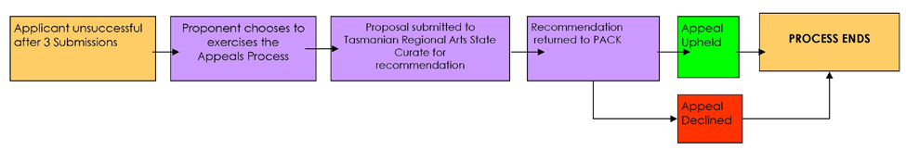
Cost of Appeal

The cost of the appeal process would be conditional upon any external advice that the state curator may need to seek in coming to a decision. However, no direct cost is charged on behalf of the PACK. The applicant would be advised that any additional charges would be billed to them directly from Tasmanian Regional Arts or the governing Arts body where external advice was required

Note: While the committee will do its best to handle appeals expediently, as third parties are required to be involved, Please allow up to 90 days to receive a final decision

Please return this form to:

The Public Arts Committee Kentish, C/- PO Box 63, Sheffield, TAS 7306

Notice of Custodianship

Organization Name ................................................................................................ Address ................................................................................................
............................................................................................... Phone .................. Mobile ................ Email ...............................
Is your organisation currently a custodian of other works? Y/N If so please detail work(s) below;
....................................................................................................................................................
....................................................................................................................................................
....................................................................................................................................................
....................................................................................................................................................

Area to be covered by Custodian (Please specify below)

E.g. Sheffield, Railton, Roland, Barrington, etc. If the area is confined to a small geographic location please attach a diagram indicating boundaries, e.g. town block

................................................................................................

................................................................................................

Genre(s) or Medium to be covered by Custodian

................................................................................................

................................................................................................

Please return this form to:

The Public Arts Committee Kentish, C/- PO Box 63, Sheffield, TAS 7306

Please note: As custodian of selected works you agree to identify and assist in the maintenance and ongoing protection of the art works above and to work collaboratively with the Public Arts Committee Kentish in managing the art works of the Kentish Public collection. The final decision to appoint custodianship rests with the Public Arts Committee Kentish.

The Public Arts Committee Kentish (PACK) is charged with the oversight of appropriate care, management and control of all public Art works that reside in the Kentish collection. To this end, the PACK reserves the right to recommend the removal of works from the collection under the following circumstances: the artwork no longer functions materially; the artwork has been irreparably damaged; artistic merit of the work falls below the level to which the collection aspires; maintenance of the work is financially unsustainable; the artwork has physically deteriorated to a point where public safety is at risk and no reasonable effort has been made by the Artist or Custodian of the work to restore it to a safe standard; there is legal evidence the work belongs to another party.

Title of Artwork

......................................................................................................................................

Location.................................................................................................................. Current Custodian(s)........................................................................................ Artist........................................................................................................................... Reason for Recommendation to Decommission
“The above work has suffered significant weather damage over recent months and the committee has been informed that no funds are available or effort is planned to restore the piece to its original condition. It is therefore the recommendation of the PACK that the piece be removed from the public collection. Please advise within 30 days if you have made arrangements to restore the piece or wish the artwork to remain in the collection and outline the reasons. The PACK is charged with decommissioning works that no longer function in their intended capacity or have degraded significantly to the point that it diminishes the wider collection. Please note that once the work has been decommissioned the committee will take the following steps, in descending order, to facilitate its removal from the collection”;

1) Offered back to the artist for an appropriate consideration;
2) Transferred to an appropriate collection for an agreed consideration;
3) Sold to approved buyers with the consent of the Artist;
4) Donated to a recognised charitable institution; or
5) Sent to a materials-based recycling depot.

All revenue obtained through the decommissioning process will be retained by the PACK for consideration in future Art developments.

The final decision to decommission an artwork rests with the Public Art Committee Kentish. Where the work resides on private property, the PACK will work with the owner regarding any decommissioning to be undertaken.

Please respond to the below address with any queries or concerns, to acknowledge receipt of this notice and/or to arrange & advise of repair or removal of the above work.

The Public Arts Committee Kentish, C/- PO Box 63, Sheffield, TAS 7306

The Public Arts Committee has received the following expression of interest for installation of
the below art work for the Kentish Public Collection

Name:
Title of Work:
Type of work: (e.g. Sculpture)
Artist:
Location: | Medium: | Dimensions:

(In the case of a three dimensional work a photo or detailed diagram of the maquette

needs to be provided)

Dimensions (mm x mm x mm)

Photo or detailed diagram

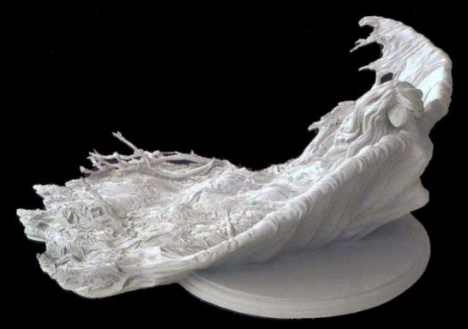Mm

Mm

Mm

Please direct any questions, comments or feedback by dd/mm/yyyy to:

The Public Arts Committee Kentish, c/- PO Box 63, Sheffield, TAS 7306

